# **Introduction to Quantum Computing**

### **A new era of computing is emerging**

Selecting transcript lines in this section will navigate to timestamp in the video

- [Jonathan] I**magine for a moment two particles each on opposite sides of the universe. When one particle is observed, the other has the exact opposite measurement.** **They are connected without communicating**. How? No one knows exactly yet, but there are some theories. **This is what Albert Einstein called, spooky action at a distance**. And it's one of the remarkable characteristics of physics of the very small. Leveraging the signs known as quantum mechanics. The operating system of nature is the basis for a completely new form of computational power. With the current progress of research and development, quantum based computing may eventually be millions of times faster than the computing power that we all use today inside our smartphones, laptop computers and other devices. Hi, I'm Jonathan Reichental, and I'm delighted to introduce you to the fundamentalS of quantum computing. This new model of information processing has moved from the theoretical to reality, with quantum computers beginning to be used for scientific and commercial use. That said, we're still in the emergence of quantum computing as a viable mainstream offering. Each day that passes gets us a little bit closer. Finally, before we get started, find two coins and have them on hand. I'll be demonstrating several concepts that you could also participate in. Now is the time to begin to learn about quantum computing. I'll introduce this complex topic to you in plain simple terms. Although occasionally I'll get a little technical to address certain curiosities. Join me as we discover the remarkable, and mind bending universe of quantum computing.

### **The current computing age**

Selecting transcript lines in this section will navigate to timestamp in the video

- Today, computers are redefining the human experience at a rapid pace, providing new solutions, greater possibilities, and unlocking the secrets of the universe. As Arthur C. Clarke, the popular science fiction writer once wrote, "**Any sufficiently advanced technology "is indistinguishable from magic."** We are both prospering and being challenged by this magic. A tweet entered on a smartphone by someone with influence can bounce around the world at light speed and quickly impact markets and political events. A medical breakthrough at a lab, once sluggish to gain traction, can now be distributed, analyzed, and further progressed by scientists from all over the world, increasing the likelihood of finding cures. Advanced software and high-performing computers are giving systems artificial intelligence, enabling machines to augment and replace routine and complex human activities. From driving cars to diagnosing disease, from sorting photographs to flying planes, from optimizing crop yields to predicting climate patterns, today's computing platforms are advancing the human experience in positive and often unpredictable ways. New technologies are also creating remarkable challenges, from the rapid erosion of privacy to questions of technology ethics that includes who should own data, and machine decision-making on our roads, in our hospitals, and in the theater of war. Our current era of computing is bringing so many of us a vast amount of continuous and new value in almost every area of our lives, but also upending so much of what used to be predictable and routine. By most measures, technology has been a boon to humanity. While it has permeated much of the globe and is often best reflected in our major cities, we must remember that several parts of the planet and far too many communities are still not connected, and thus, not realizing its benefits. As of early 2019, almost 1/2 of the world's population still doesn't have access to the Internet. The news is promising, though. Internet connectivity is rapidly expanding. Our current computing age can be defined by astounding progress and capability metered with a series of serious concerns. A platform that allows for the building of online communities that serve and help the less fortunate is the same platform that can be leveraged to spread harm and hate. Our biggest and toughest challenges are all ahead of us. As technology spreads to every corner of the world, as it touches every aspect of the human experience, as it even redefines what it means to be human, we will face complexity and choices that will make today's issues seem easy. Today's computing power is enabling more people to prosper than ever before. It's also providing us with a larger toolkit of options to solve the biggest challenges. Areas such as the existential risks of climate change, for space exploration, for building better and smarter cities, for leaps in medical possibilities like CRISPR that enables us to edit our genomes and change their function, for improved manufacturing and materials, more immersive entertainment, and healthier food production. Of course, we'll also see an increase in nefarious uses of technology, increased cybersecurity risks, and challenges to human jobs as robots and artificial intelligence play increasing roles. We'll see the social impacts of too much screen time and all this increased technology use will place even greater pressure on our existing energy systems. Side by side, the benefits of our technologically-powered society far outweigh the negatives, but we face one inevitable challenge ahead on this largely positive curve. We'll soon experience the physical limits of our existing computing capabilities. If we are going to be unsatisfied with contending with an upper limit of computing performance, and I'm confident that this will be the case, we'll need a new computing paradigm. Without it, the rate of progress that we've come to expect may slow down. It will be needed to support the innovation in computing performance necessary in the decades ahead. This is where quantum computing, which may usher in a new era of computing possibilities, will play an essential role. It won't be the only technology to move us forward, but it'll be an important and game-changing one.

### **A brief history of the third industrial revolution**

Selecting transcript lines in this section will navigate to timestamp in the video

- Understanding history helps us to make sense of our times and where we may be trending in the future. To get a better grasp on the context for a new generation of computing power we'll briefly review the human journey that has brought us here. We won't go back too far but instead focus on a series of revolutions with an emphasis on the Third Industrial Revolution. For much of human history we were farmers and craftspeople. We lived off the land and produced most goods by hand. It is only 300 years ago in 18th Century Britain that the nature of the human experience radically shifts and changes the world. In particular, the use of steam power, railways, and steel, among many transformative innovations, ushered in an age of mechanical production and transport. Factories and rapid urbanization changed how we lived, worked, and played. This first Industrial Revolution created a sharp turn in human destiny that has shaped our world to this day. Barely 100 years later another revolution got underway that was largely defined by the deployment of electricity at scale and the phenomena of mass production. Electricity, for example, enabled the invention of the telephone, a singular technology of consequence. The era of global telecommunications began in earnest and still continues today. Both of these Industrial Revolutions set the stage for a third Industrial Revolution. It began in the 1940s. As steam power and electricity largely defined the core technologies of the previous transformations, the invention of the transistor was at the heart of the third revolution. Accelerated by the U.S. space program, the popularity of radio, and later commercial applications such as the handheld calculator, transistors enabled the miniaturization of electrical switches. Switches enable or disable the flow of electricity. To be on or off, so to speak. They are the essential building blocks of electronics and modern computing. Miniaturization of switches or transistors resulted in the microchips we have today. The low cost mass production of microchips democratized computing and thrust the world into a third Industrial Revolution. Rather than analog innovation, this revolution has largely been defined by digitization. In other words, taking analog information, that which is not electronic in nature, and converting it to the language of computers. Ones and zeroes, on and off switches, so that can be stored, processed, and transmitted electronically. Digitization is ubiquitous today. It powers just about every electronic device we use. It has enabled the creation of the internet and the World Wide Web, two platforms that no one would argue have altered the course of history. In fact, where the internet takes us and the complex challenges it presents in the years ahead, is still a story to be told. The third Industrial Revolution, built on transistors made from silicon, continues to define our current times. Our digital world has modified our destiny and created completely new opportunities and challenges. The benefits of remarkable computing power teases us at what may be possible in the future, as we increase performance and intelligence in our hardware and software. Even as the third Industrial Revolution plays out, a new wave of change is beginning to emerge. The convergence of the digital, physical, and biological worlds combined with new global demographics and economics, is hinting at the opening stages of a fourth Industrial Revolution. While it's still early the evidence of even more radical and disruptive change for humanity is ahead, without question, quantum computing will be a central player in this new revolution.

### **A simple explanation of classical computing**

Selecting transcript lines in this section will navigate to timestamp in the video

- Quantum computing is a new way of processing information. It's quite different when compared with how computers work today. To really grasp the nature of quantum, it's valuable to understand just how significant the difference is. To achieve this, let's look at how today's computing, something we call classical or binary computing, works at a very basic level. At the heart of today's computing is the essential role of electricity. Electricity is energy and is powered by electrons. Tiny particles that orbit around atoms. Electrons can remain tied to a particular atom, which we call static electricity, or they can be made to move from atom to atom which is called current electricity. Electrons need material called conductors to move. Materials that stop electrons flowing are called insulators. An ability to both conduct and be an insulator under certain conditions is a property called semi-conducting. Silicone, for example, is a semi conductor. Let's look at a familiar example of current electricity. To turn a light on, electricity must flow through conducting material from a switch to a bulb. Copper wire is an excellent conductor. When the switch is on electrons flow and power the light bulb. When the circuit, the name for the system, is broken, that is the switch is in the off position, no electrons flow and the light bulb powers off. This concept of a switch which enables or disables the flow of electricity is almost everything you need to know to understand how classical computing works. In computing, we call these switches transistors. Let's explore this further. A switch that is on or off represents just two states. This is called binary. Let's say that a switch that is on is a one and an off switch is a zero. By controlling the flow of electricity between on and off, we can get a series of ones and zeros. These are called binary bits. A unique series of these ones and zeros can each equate to say, the letters of the alphabet. For example, the computer science community agreed, a long time ago, that the following series of bits, 01000111 is the letter G. A single switch is interesting itself but when we combine switches, we can begin to do cool things like mathematics. This is achieved because with at least two switches there are multiple combinations that can instruct electricity to flow in certain directions. For example, if both switches are open, we can direct electricity flow in a specific direction. If one is closed and the other is open, we can direct it elsewhere. By defining these conditions, called logic gates, we achieve a variety of outputs. If we combine many switches together, hundreds, thousands, or more, the binary output communicates complex instructions. Today high end microchips contain billions of transistors, yes, billions. Take a look at one of those coins that I asked you to have on hand during the introduction. That's roughly the size of a microchip. And some chips are much smaller than this one. Those billions of transistors must be tiny. Innovation over the past few decades has enabled us to further miniaturize the technology, enabling more and more transistors on the same small microchip real estate. These transistors equate to faster processors. Basically this results in more instructions being processed in less time. What is striking about this architecture is that it's fundamental construction is simple. Each discreet transaction is just one of two states. A one, or a zero, but this has enabled the most powerful machines humans have ever created. Our coins are a good metaphor for binary states. Place your two coins on the table. Even though there are two sides to each, we can only read one side from both of them. Today's computing handles this well. In coin parlance, a bit can only be a heads or tales at any given moment. We've had a good run with miniaturization. After all the processing capability today in our small smartphones is remarkable. There are enough transistors in them to provide for a long period of usefulness. With really complex scientific problems, we use much larger computers because they need many more processors. Big, wicked calculations can take hours, and sometimes days to compute, even with the best of today's computing capabilities. We are gradually approaching at least two limiting dimensions. First, we are closing in on the physical constraints of how small a transistor can be and still function and secondly the next era of processing needs for a wide range of human aspirations will take far too long using current computing technology. To solve these challenges, we're going to need a new computing paradigm. Quantum may hold the answer.

### **Drivers of the next generation of computing**

Selecting transcript lines in this section will navigate to timestamp in the video

- So why might classical computing not continue to meet our needs? What is driving our rapid movement towards a next generation of computing power? I've been involved in using and working with computers for over 30 years. In that time, processing speed has continued to increase rapidly with each new generation of microchips. The cost of computing has also rapidly dropped. Just look at storage costs. In the 1990s, a gigabyte was almost $100,000. Today, it is less that 10 cents. Software capability has empowered remarkable new business models, from on-demand mobility to global online commerce. At no time have our expectations of what technology can provide plateaued. Moreover, our appetite for innovation has only increased. I've come to expect, like you, that computing technology will just continue to get faster, better, and cheaper as time passes. We're not yet near a time when current capabilities will fail to meet our needs. This is particularly true in the consumer and enterprise space. Today's computing continues to take us places we didn't expect with fast, re-imagined, and connected services. Available on our ever-expanding number of devices. A hyper-connected, data-driven planet though doesn't stand still. As every organization becomes a technology organization at its core, as more data is created, stored, and leveraged, as software drives more solutions and computing intelligence gets baked into everything, as our ambition and confidence increases to tackle our most intractable issues, our needs are catching up with the capacity for classical computing to deliver. Here are a few specific examples of drivers of a next generation of computing. The first example is our need for better cybersecurity. Old benefits of a digital connected world have only increased the potential for security issues. A day doesn't pass where we don't hear about another significant security breach. Cybersecurity technology is innovating quickly, but bad actors are evolving quickly too. Current approaches, including widely adopted encryption technologies, will eventually become less effective. Ironically, it may be quantum computing that eventually breaks current encryption techniques. To insure a more secure, appropriately-scaled response to our hyper-digital, connected future, we'll require new approaches and new technology. In it's absence, a lack of public trust will hinder progress and may have limiting consequences, such as burdensome regulation, that we may later come to regret. Quantum is poised to offer the kind of cybersecurity that the future will demand. Now the second example. Our need to advance our understanding of biology, physics, and chemistry. While we've come a long way in understanding our universe and our planet, there's still much we don't understand. Supercomputers are enabling us to better understand molecule interactions, but modeling takes time and has processing constraints. Anticipating the weather and more broadly understanding our climate over time already tests the most advanced computers. Drug research needs better performance capabilities to design a new generation of treatments, including the creation of personalized solutions. A drug designed for a single individual for their unique body and health issue. Surprisingly, quantum computing may also be essential to furthering our understanding of quantum computing and the quantum mechanics space in general. I know, that's very meta. Researchers are excited about the possibilities of this new technology helping to understand and advance innovation in quantum itself. And finally the third example, global competitiveness. Can we possibly imagine a world were one nation is powering forward with significantly better computing power than others? For example, could the United States continue to rely on classical computing, while China, Russia, and the European Union rapidly make advances in computing that is millions of times faster? Today, an economy left behind in technological capability will quickly struggle. After all, the painful evidence of history already proves this. The promise of a new computing performance is motivation enough for many countries to be in this race. And in it they are, with quantum computing nations big and small across the world are investing heavily. And many have made it national priority.

## **Question 1 of 3**

At any given moment, what value can a single bit have?

* any letter
* any number
* both one and zero
* one or zero  
  Correct  
  At any moment, a bit could either hold a value of one or zero.

## **Question 2 of 3**

Why is a new computing paradigm needed?

* Computers can help more with food production.
* Existing computers are contributing to the climate change problem.
* Existing technology causes too much social disruption due to screen time.
* Current computing capabilities are reaching physical limits.  
  Correct  
  To keep our rate of progress, computing performance must break through existing physical limits.

## **Question 3 of 3**

With current electricity, electrons are _____.

* flowing through an insulating material
* flowing through a switch, even if it's in the off position
* moving from atom to atom  
  Correct  
  Current electricity is the movement of electrons from one atom to another.
* tied to a particular atom

### **What exactly is this quantum stuff?**

Selecting transcript lines in this section will navigate to timestamp in the video

- I don't know about you but for me terms such as quantum mechanics, quantum physics and quantum computing all have an exotic and mysterious allure to them. I immediately think of a world of science that remains hidden to most by complexity and only understandable by a few. There's a reason this domain of science appears this way. It's complex. It often requires specific prerequisite knowledge of physics and mathematics and it challenges some of our basic understanding of science that we learned in school. With the eventual arrival of quantum computing to a much broader audience, it's time for us to begin to peal back some of these veil of mystique. In doing so, we will reveal and discuss some basic quantum mechanics phenomena with simple language. A deeper understanding is best left for a more scientific exploration at another time. So, let's get into it. In discussing classical computing earlier, we noted the essential role of electrons. Those particles that orbit around an atom. The movement of electrons between atoms creates electrical current. The necessary ingredient of a transistor to carry out its job. As electrons move around a circuit, we generally have certainty about their location, speed and timing. For example, if a series of transistors are engaged in a certain way, we generally know when, where and how fast electrons will arrive at a specific location. It's a predictable and measurable science. Today's computing is based on what is termed classical mechanics. However, at the turn of the 20th century, a series of discoveries by several scientists resulted in questions about the predictability of the behavior of particle**s. For example, while researching deep in the smallest discrete unit of a physical property, called a quantum, results question the certainty of a particle's behavior and location at a given time. Scientists concluded that this behavior may in fact be subject to probability. While at first thought to be mistakes in the complex mathematics that derive these conclusions, later validation proved otherwise. These discoveries were strange, unexpected and very exciting. Research in this area, that is the ability to describe through various means the interaction and motion of subatomic particles would become known as quantum mechanics.** **Suddenly our long-held beliefs about the nature of the physical universe was not as straightforward as previously thought. Other quantum phenomena discovered at the time was that light could be behave like a particle, not limiting itself to the nature of being a wave and particles could have properties of waves. It would become known as wave-particle duality. I**t is enough to understand that up to this point of this important discovery, scientists assumed that because waves and particles were entirely different, they did not occupy the same physical domain. In the 1920s, an experiment demonstrated light waves colliding with particles thus proving this remarkable theory. While it may now seem unintuitive, it is important to point out that classical and quantum mechanics are not in conflict with one another. Through rigorous experiments and mathematics, the unusual nature of science at quantum scale is still consistent with our observations of physics at a larger scale. **The subatomic probabilistic nature of quantum mechanics enables classical mechanics which manifests statistically accurate as we predicted at a larger scale. Thus it could also be concluded that by extension quantum ultimately explains classical computing. Among many revelations, quantum mechanics has helped to explain what keeps electrons in orbit around an atom.** How atoms bond to produce molecules. And it is just beginning to provide us with clues as to what dark matter might be and the nature of black holes. It's helping us understand both the smallest and largest objects in the known universe. It has been hoped that the discovery of the nature of quantum mechanics would result in a unified theory of everything. Notable quantum scientists, Albert Einstein, and Stephen Hawking, among others, labored passionately to land on this equation, the ultimate human prize to explain the universe as we know it. However, this goal has remained elusive. Quantum mechanics has helped us understand science but it's worth noting that many questions remain unanswered. The greatest discoveries are still ahead of us. While it's not necessary to understand the full implications of all of this, it's enough to know that the discovery of these new properties of subatomic physics has challenged our traditional understanding of science and it's providing more satisfying explanations for the mechanics of the universe while also creating many questions. Our understanding of quantum mechanics has opened a vast array of new possibilities including the science that would eventually enable the first experiments in quantum computing.

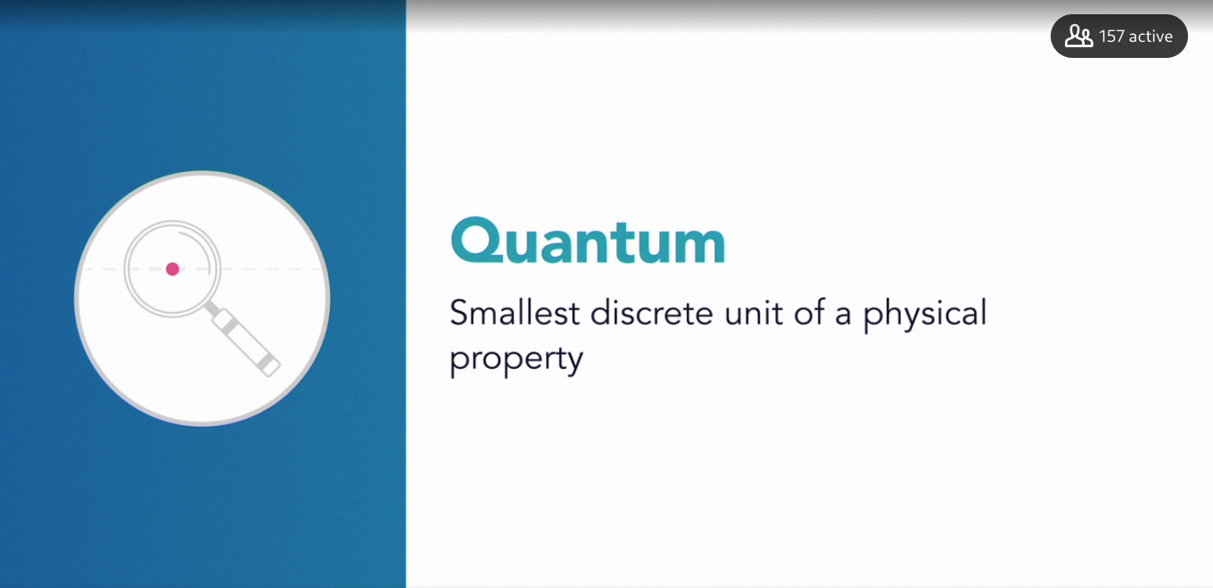

### **A brief timeline of quantum research to date**

Selecting transcript lines in this section will navigate to timestamp in the video

- Given the recent increased interest in quantum computing, it may seem like it's a new area of research and development. Some of the biggest breakthroughs are happening now, but quantum computing and quantum mechanics more broadly already has an illustrious history. Let's look at some of the major milestones along the way and the notable scientists attributed to them. In the mid to late 1800s, a series of discoveries in physics emerged that provided the basis for a handful of defining quantum physics milestones. In the early 1900s, a German theoretical physicist, Max Planck, contributed significantly to our understanding of the nature and behavior of matter and energy at the atomic and subatomic level. He is best known for his quantum theory of energy. His work in this area won him the Nobel Prize in Physics in 1918. Albert Einstein, another notable German physicist, built upon Planck's quantum theory to describe the particle properties of light. He demonstrated that electromagnetic radiation, including light, had the characteristics of both a wave and a particle. These discovered quantum particles of light were later called photons. In the early 1920s, these new theories and discoveries in the quantum realm led to the coining of the term quantum mechanics by a group of German physicists, Max Born, Werner Heisenberg, and Wolfgang Pauli. The terms quantum mechanics, quantum physics, and quantum theory, while having subtle and important differences to scientists, are generally acceptable as meaning the same thing. From the 1920s through the 1950s, major discoveries were made on the nature of atoms and their subatomic behaviors and processes. More knowledge emerged on the workings of electrons, protons, neutrons, photons, neutrinos, particles, and waves. With each discovery, physics became more exotic. For example, German physicist Werner Heisenberg asserted that there existed a fundamental limit to the precision by which certain pairs of physical properties of a particle could be known. His most famous principle, introduced in 1927, known as Heisenberg's uncertainty principle, states that the more precisely the position of a particle is determined, the less precisely its momentum is known, and vice versa. There are several notable milestones in the emergence of quantum computing, beginning in the early 1970s. In a 1975 paper, Roman Ingarden, a Polish mathematical physicist, proposed a quantum information theory. This theory described how quantum information, like classical information, could be processed, transmitted, and analyzed. Unlike classical computing, though, which relies on binary bits, quantum processing would use quantum bits, or qubits, and work entirely different. In the early 1980s, it is a combination of several scientists, including Paul Benioff, Yuri Manin, and Richard Feynman, who solidify the basic principles of quantum computing. Feynman, an American theoretical physicist, is notable. He had previously won a Nobel Prize for Physics in 1965 for his contribution towards the development of quantum electrodynamics. A remarkable scientist, he also worked on the atomic bomb and introduced the concept of nanotechnology. He's often credited with being the pioneer of quantum computing. In addition, a British physicist, David Deutsch, is called the father of quantum computing for his breakthrough work on quantum computation and for being one of the first to specify an algorithm designed to run exponentially faster under quantum conditions. In the early 1990s, research conducted in the United States by Bell Labs and the U.S. Government, together with several leading international universities, set the stage for the construction of the first physical quantum computers. Around 1998, the first functioning computers emerged. During the early 2000s and into the 2010s, quantum computing research and development significantly accelerated. Today there are many different types of quantum computers developed by a variety of producers, both commercial and noncommercial. There isn't yet a consumer product you can buy in a store or online, but enterprises are already utilizing them. As an individual, though, you can tap into quantum capability being provided by several entities. More on that a little later.

### **What is quantum computing?**

Selecting transcript lines in this section will navigate to timestamp in the video

- After several decades of microchip success, we are now approaching its physical limitations. At some point, chips and their transistors will be closing in on the scale of atoms which will likely trigger quantum phenomenon. Electrons which are supposed to flow predictably will behave unpredictably and may pass through solid surfaces or even teleport mysteriously to another part of the chip, in what's called quantum tunneling. I'm serious. In other words, at some point, it's not going to be possible to miniaturize much further. However, we won't see the end of classically computing for some time. We'll be able to squeeze plenty of increased performance out of it. We should also anticipate that it will exist in concert with any new emerging computing platforms. Ultimately though, if we're going to enter the next era of computing to support our future needs, we'll need a new computing model that has significantly more processing performance. - Yeah, I think it's always hard to tell exactly when something is going to happen. You know, we say, you know, five years out but I think the real thing to think about here is that quantum computing is coming. There are enough people like us and Google and IBM that we have a lot of smart people and we're spending a lot of money and it's going to happen. Could be a couple years. Could be five years. Likely within this decade for sure that it'll happen. And then you have to, like, take a look at before it happens, you need to train and develop and have the skills to be prepared for when it happens. It's a completely different want to do computing. It's different than classical computing. The algorithms are different. The way that you do computation is different. You really need to start training now to be prepared for it and there are actually some opportunities where you can learn on a classical computer about quantum computing to prepare you for that quantum computer when it does come. - **The difference between classical and quantum computing can be superficially summarized as follows. While classical computing is limited to processing just one of two states at any given time, a one or a zero, binary bits, quantum computing leverages what are called quantum bits, or qubits. These are an induced property of a subatomic particle that can represent a one, zero, both and any value in between, surprisingly, all at the same time. It's a quantum phenomenon called superposition. - So there is a great example in physics experiments illustrating exactly that point. It's called Double Slit experiment.** So it's experiment where you have, say, a board and you have another board with two slits and you're just sending lights, light through these two slits. So if the light was a classical, you know, if light was a classical object, classical matter, then depending on, you know, right or left slit, it would just go through right or left slits, right? Because classical particle can be at one position at a time, right? So it just goes through right or left. However, quantum mechanics, in principle, superposition of quantum mechanics, allows the light to go through both slits at the same time and therefore, on the background, you would see a very characteristic pattern. So, it's not a pattern where you have light at one point or the other. It's a light where you have these dark and bright patterns and these dark and bright patterns basically indicate we're dealing with quantum matter, which goes through both of them, both of the slits at the same time. And this actual example illustrates the power of quantum mechanics because let's imagine I have hundreds of these slits and let's imagine I will close one of them and I'll say, which one did I close. If it were a classical matter, then you would have to try each slit, you know, consecutively. So that would require over a hundred of operations just to try and see which one is closed, which one is open but quantum mechanics, and, you know, this principle of superposition will provide a unique answer and, you know, by looking at the pattern on the screen, one can identify which slit was closed in one shot, in one measurement. - Note, however, that when a quantum state must be measured, **it does collapse into a state of one or zero, something called a wave-function collapse**. Yes, even the final output from a qubit is a binary number. That's great news because it enables it to feed into our classical computing architecture. In quantum mechanics, the idea that a particle can exist in multiple states until it is measured at a point in time is called the Copenhagen Interpretation. It was proposed by Niels Bohr and Werner Heisenberg in the 1920's. A famous thought experiment to help grasp this concept is called Schrodinger's cat, devised by Austrian physicist Erwin Schrodinger in 1935. In simple terms, if a cat is placed in a closed box and small amounts of poison are administered, it's possible that the cat could be die but equally, it's possible that there is not enough poison for the cat to die. For the observer outside the box who cannot see the cat, it can be said that the cat is theoretically both alive and dead. It's only when the box is opened and the cat is observed that the state of the cat can be determined. Understanding quantum physics and its application in quantum computing is complex. For most of us, we'll never need to fully understand or grasp some of the deeper unintuitive concepts. In fact, even quantum physicists still struggle with the unusual behavior of particles and waves at the smallest level. So let me summarize. Quantum computing results from eliminating the binary state constraints of classical computing. Rather than simply being limited to a one or a zero in sequence, quantum computing introduces the possibility of multiple states processed in parallel. Right now, we don't know if that could be built. However, there's growing evidence that we are headed in that direction.

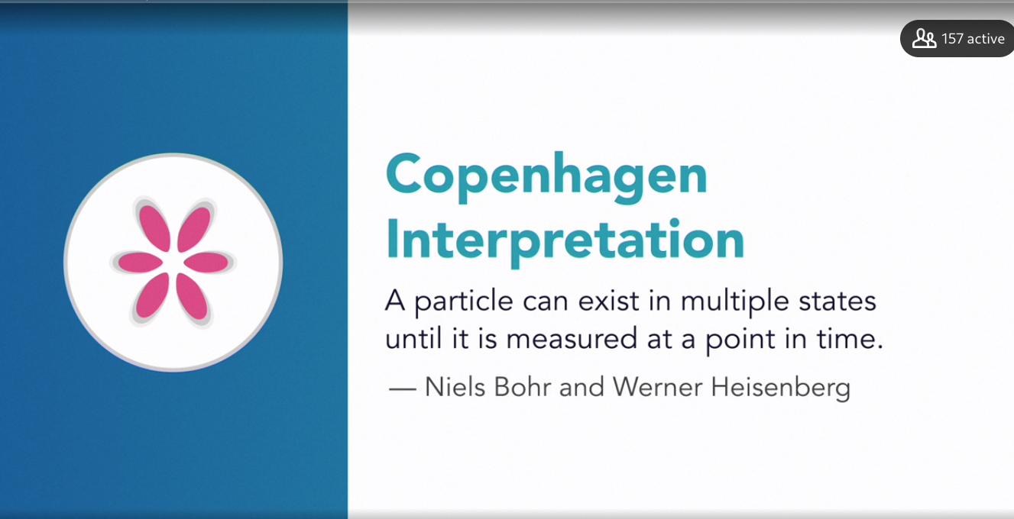

### **Superposition: The core idea in quantum computing**

Selecting transcript lines in this section will navigate to timestamp in the video

- We look in the ocean and we see waves, or a pond, and you drop a rock in a pond and you see waves ripple out. And if you drop a rock in a different point of the pond, at the same time, then you see waves ripple, and then they come together and the waves form superpositions. You'll have crests and troughs that add and subtract from each other in some coherent way that can be destructive or constructive. - So what would happen if we could have a computational model that can manage a one, zero, or both all at the same time? **This is what a qubit is. The ability for a qubit to have multiple states simultaneously is called superposition. It's the physics of quantum mechanics that enables particles and waves to be in multiple states until measured, at which point they collapse to either a one or zero**. **Qubits are created by changing the state of certain atoms and other quantum-scale particles. Electrons, the nucleus, and even photons can be used. To change an electron into a qubit, we can use laser beams, electromagnetic fields, radio waves, and other techniques.** Let me use an example to further explain this idea of multiple states until measured. For this, we'll use one of our coins. I'm going to go ahead and spin this on the table. Is it currently heads or tails? As the coin is spinning, it's neither. It's only when it comes to a rest that we know whether it will be heads or tails. So this binary device, a coin, with only two sides when spinning, it technically in multiple states. If it were a qubit, it will be in a state called superposition. What does this mean in practice? **- So we have superposition, we have entanglement, and there's another really key element for quantum algorithms, and that's interference. And so, when we think about interference, how does that work, what does that mean? If you imagine a tide pool, and you create a ripple. I touch the corner of the pool and then I touch the corner on the other side of the pool, and this creates waves. So in quantum mechanics, waves play a very large role. This creates waves in that pool. And as those waves ripple across, they interact, they interfere. When those waves interfere, you can see that the height, the amplitude of those waves, some of them, the amplitude grows, they get taller. Some of them, in fact, disappear. Some of those waves disappear, they cancel each other out. This is actually exactly what we use in the design of quantum algorithms, the notion of some of these waves causing amplitudes to increase and magnify, and some of the waves to disappear. Now, the key is encoding your solution into those waves. All of the possible solutions become, in some sense, one of these waves. And so, the wrong solutions, you want to interfere and cancel each other out. And the correct solutions, you want to interfere and magnify, amplify. And that's exactly how we design quantum algorithms. - A classical computing model will try each possible solution in sequence until it reaches the correct answer.** A quantum computer would guess many answers in parallel, thus finding the solution in no time at all. **Qubits are at the center of what makes quantum computing work. Today, we are able to tie a few qubits together to create quantum gates, their equivalent of logic gates. You'll recall these gates are what take an input, test it, and then create a new output.** In classical computing, these are called Boolean operators, like an and, and an or. Quantum gates are conceptually similar. Finally, quantum computing, while is already achieving remarkable results, has some big challenges to overcome. Among them is managing qubits. Both vibration and changes in temperature quickly make them unstable, this can hinder computation or cause errors in the output. We need to solve and address these current limitations if quantum computing is to become reliable and used with confidence.

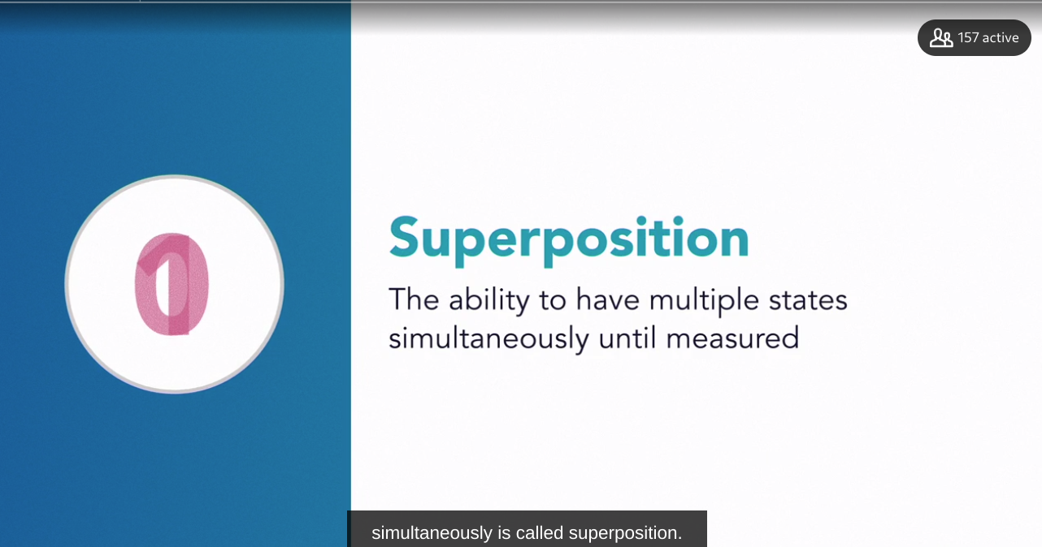

### **Entanglement and other fun concepts**

Selecting transcript lines in this section will navigate to timestamp in the video

- Entanglement has the most important difference is that it's not predetermined. T**here's nothing there yet, unless you make a decision, and so it's basic the most important thing is there's really nothing yet. There's no something, it's a state before you do anything, but once you do to one side, you have a state, and then the other side is also determined.** - When we speak of quantum mechanics, **we're referring to the behavior of science at the atomic and subatomic scale. As we approach the fundamental, tiny building blocks of the universe, things get weird. Our human knowledge of how things work, and how they should work based on traditional science, gets much fuzzier too.** I find this exciting because it reminds us of how much knowledge we still have to learn, and that there are enormous opportunities for a new generation of researchers and scientists who may emerge from anywhere in the world. Let's focus on two important quantum concepts. **A rather unusual characteristic of quantum mechanics is something called entanglement. This is when two particles that have no physical connection respond to each other as if they know about each other. It's so peculiar and unexplainable that Albert Einstein called it spooky action at a distance. He was known, as were many of his physicist colleagues, to be uncomfortable with this unexplained phenomena. To explain it more clearly, let me provide an example using our coins.** I'm going to go ahead and spin these two coins on the table. (coin spinning) If we stop one of the coins, it will rest on heads or tails. If these two coins were entangled, the other coin would also stop, and it would rest on the other side of the coin to the one we stopped. It's as if both coins know about each other. No matter which one we stop first, and which side it rests on, the other will also stop and rest on the opposite site. In quantum entanglement these coins are particles, and they can be any distance from each other. In fact, both could be on opposite sides of the universe. When one particle is observed, the other has the exact opposite measurement. **They are connected without communicating. How? No one knows exactly yet, but there are some theories. Perhaps, as some believe, quantum entanglement is in some way what is holding the universe together. So how does quantum entanglement factor into quantum computing?** Previously we explored the quantum equivalent of a classical bit, called a qubit. **A qubit spins until observed, and then it assumes an up or down position, a one or a zero. If two qubits are placed into an entangled state, it means that when one of the qubits is known, we immediately know the other. If we tie together many qubits, their entangled partners will be known at time of measurement. Let's look at how quickly this stacks up. Two qubits represent four states, zero zero, zero one, one zero, and one one.** **Three represent eight states, zero zero zero, zero zero one, zero one zero, zero one one, one zero zero, one zero one, one one zero, and one one one. Twenty entangled qubits can store two to the power of 20, or over one million values.** **That's remarkably efficient. Compared to classical computing, where each bit, a one or a zero, is evaluated in sequence, qubit at scale produces enormous computational outputs in parallel. Here this is tough but fascinating stuff. Don't worry about the details. I've glazed over most of this to communicate the core concept of entanglement. The second concept I will cover is called quantum decoherence**. Q**ubits are created using specific atomic particles, or even photons, which are light waves. An electron of phosphorus is an example. To begin the process of creating a qubit, the atoms are placed in a superconducting magnet. This forces the electron into what we call a spin-down position. In a normal temperature environment, the electron's spin direction is not stable, as heat produces energy, forcing the electron to get excited and move. To create stability, the environment needs to be contained in a supercooled refrigerator. For now, the need for large cooling systems ensures that quantum computers will be quite big for some time. Now to get the electron to spin up, a pulse of microwaves must be fired at it. Stopping the microwaves at a point anywhere between spin-down and spin-up creates a superposition.** **It is now a stable, coherent cubit.** Okay, that's as complex as I'm going to get. Pretty neat, though, right? However, everything I just described in creating a qubit is fragile. Any changes to temperature, light, sound, vibration, and other external factors will impact the qubit's state. - You know, in an abstract sense, what that's saying is that if you deform things little bit, make small errors, they're robust. And it turns out that there are some quantum states of matter that have very similar mathematically identical type of robustness, and so topological quantum computers based on using as your physical platform those kinds of quantum states of matter. And so a lot of the research here at Microsoft, the big technical challenge for us is to controllably make those quantum states of matter in the laboratory, and ultimately in quantum hardware, so that you will have intrinsically, inherently, much more coherent, more stable qubits. **That said, decoherenece also explains how quantum mechanics is the basis of classical mechanics. Decoherence ends the quantum state, and the traditional signs of atoms and larger things function as expected. It's why quantum is ultimately compatible and consistent with the world as we know it.**

## **Question 1 of 4**

**What does the Heisenberg uncertainty principle state?**

* **There are many particles, including protons and neutrons.**
* **Energy has a quantum nature.**
* **A more accurate knowledge of a particle position reduces our knowledge of its momentum.  
  Correct  
  According to the Heisenberg uncertainty principle, accurately knowing a position reduces our knowledge of momentum.**
* **Electric radiation has properties of both a wave and a particle.  
  Incorrect  
  The discovery that electric radiation has properties of both a wave and a particle is different from the Heisenberg uncertainty principle.**

## **Question 2 of 4**

**The phenomenon that occurs when two particles respond to each other, even when they have no physical connection between them, is called _____.**

* **entanglement  
  Correct  
  Entanglement is the scenario when two particles that have no physical connection respond to each other.**
* **decoherence**
* **predetermination**
* **spin-down**

## **Question 3 of 4**

**What is quantum mechanics?**

* **the unified theory of everything**
* **the theory that explains how light behaves under classical physics**
* **a method to connect multiple transistors to work in tandem in one circuit**
* **the ability to describe the interaction and motion of subatomic particles  
  Correct  
  Quantum mechanics describes the interaction and motion of subatomic particles.**

## **Question 4 of 4**

**What advantage does quantum computing offer over classic computing?**

* **faster processing of zeros and ones**
* **supporting additional binary numbers**
* **processing multiple states in parallel  
  Correct  
  Quantum computing is not restricted to binary state constraints, and can process multiple states in parallel.**
* **running calculations on a remote computer**

### **The current state of quantum computing research**

Selecting transcript lines in this section will navigate to timestamp in the video

- By now, I hope you're as excited and intrigued as I am about the possibility of quantum computers. After all, they promise to usher in a new age of computing and to enable completely new ways for technology to serve humanity. The potential is so alluring. We want this capability now. Quantum computing is still an emerging technology. What major breakthroughs are required for it to enter the mainstream? - Taking the whole topological area as a whole, the main breakthrough that we're going after right now is getting even just the first functioning topological qubit. So it's really the most basic building block of the whole system, of the whole approach. The hope is that once we just get that first building block going or the first couple building blocks going, things will just snowball and take off from there in a way that is a lot easier than these other systems like superconducting qubits or whatnot. - [Man In Black Jacket] The technology for creating a qubit ranges from superconducting magnetism to microwaves and to lasers. Each has strengths and are being extensively tested. It's not yet clear which approach will achieve the best results. - **Quantum states, because of their complexity, which is why we like them so much for information processing, also means that the types of errors you can have are also more complex and more in variety. As a result, to correct those errors, there's so much overhead involved in correcting errors that the error rate to begin with is extremely small, much smaller than for classical communication or a classical computer. That error rate is extremely small to begin with. The whole thing is going to just actually spin out of control, and as you try to correct errors, you'll make more errors, and actually error rate will just increase, and you'll never get anything done. On the other hand, if the starting error rate is good, good enough, then you actually revert your cycle which is the more error connection you do, the lower the error rate's going to get.** **Unfortunately, that also means that you're spending most of your computing time just playing whack-a-mole. You're just trying to correct errors, and all you're doing is error connection, barely any actual useful computation. So you really need the error rate to get down and having what you might call higher quality, more stable, higher fidelity qubits is really the big breakthrough that the whole field is trying to push towards.** There has been some focus on getting more qubits, but more qubits is only going to get you so far until you make them higher quality. - While classical computers have excellent fault tolerance, that is the ability to continue to operate effectively despite errors, quantum fault tolerance is still an emerging area. Quantum computers will need a lot more than just the ability to create and leverage qubits. They'll need new software and interfaces and a whole range of yet-to-be-invented technologies to integrate them into our existing ecosystems of technology. You can't just run classical computing software that works with binary bits on a system that uses qubits. In other words, PC-based Microsoft Windows can't be installed on a quantum computer. Quantum computers need their own algorithms, operating systems, and programming platforms. Classical computing software evolved over decades and was represented by generations of software. The first generation was programming at the machine code level with ones and zeroes, and several generations later, it had become easier through abstraction. That is, you can now build software by simply dragging and dropping visual icons. We'll need to see these tools developed, and they are being developed for qubit-powered computers. So it becomes clear that quantum computers exist and are getting results, but there are major technological gaps to fill. However, innovation is moving quickly. While we are addressing the hardware and software needs, we also need to see more participants in the quantum computing marketplace. This will happen when it becomes more evident what the timeline is for broader adoption. We'll also need a lot more talent to cross the board from analysts to developers to engineers and implementers to strategy advisors to documentation writers and more. Greater investment in startups and more university participation will be required too. In general, we're trending in a positive direction in all these areas. The future of quantum computing looks very promising indeed.

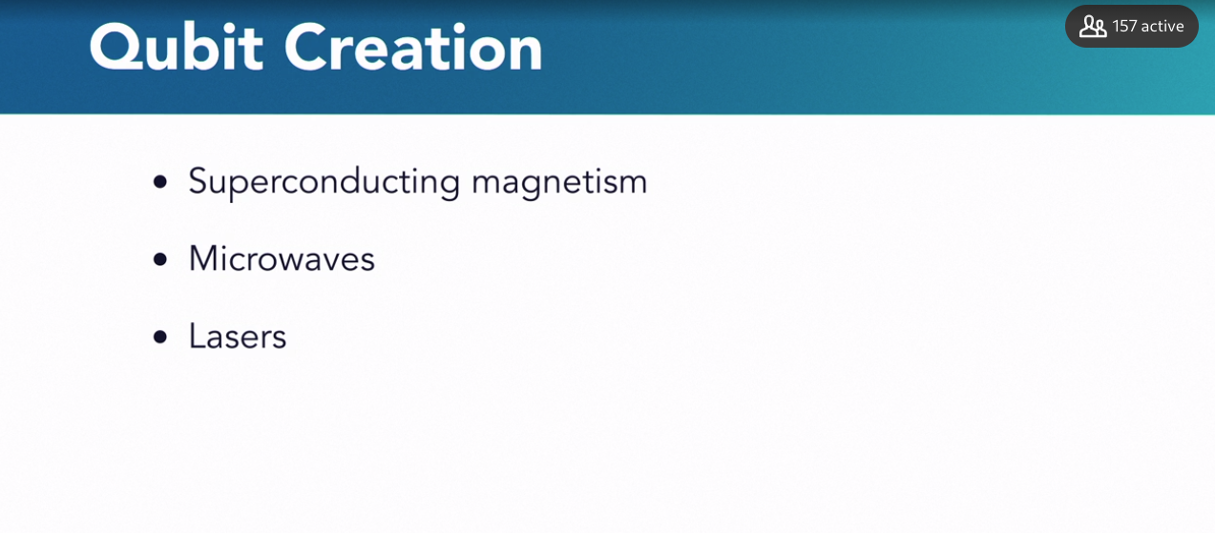

### **Examples of quantum computing implementations**

Selecting transcript lines in this section will navigate to timestamp in the video

- For much of history of quantum computing, the concepts were theoretical and documented in complex mathematics. Fortunately, since the late 1990s, actual quantum computers have been built. Since that time, major advances have been made. Systems that support many qubits are now being used, albeit in an advanced, experimental stage. They're available for both enterprises and individuals to use. Much work remains and a high performance, fault-tolerant solution does not yet exist. Let's explore a few examples of actual quantum computing implementations. IBM is a major quantum computing player. They have been researching and experimenting in the space for many years. Today, they have several physical prototype machines and simulators. Called the Q series, these computers are in a few global locations. They differ in their implementations, including number of qubits supported, which range from five to 32. These systems are available to the public to use. I**BM does have experimental machines with higher qubit counts but are not available for public use. IBM also provides an open source quantum software development kit called Qiskit and a virtual interface for coding called IBM Q Experience. Detailed information is provided on IBM's quantum computing website, regarding these implementations and how to access and use them. Microsoft has been working on both the hardware and software for quantum computers for over a decade. Their quantum-focused programing language is called Q# and has integration with Visual Studio and the Python language. It enables development on Windows, Mac OS, and Linux. Microsoft believes, as do many, that classical and quantum computing will work together, at least for the foreseeable future. A classical computer would determine if a workload would be best processed in a quantum computer.** If it is, the workload will be uploaded to a quantum computing platform and then results will be made available through Microsoft's Azure service. Google is now deep in the quantum computing research and development business. Their focus is on quantum powering artificial intelligence, developed through both hardware and software. **Their current quantum processor called Bristlecone supports 72 qubits. They also offer two open source platforms, Cirq, which is for experimenting with quantum algorithms, and OpenFermion, which is for working on problems associated with chemical and material sciences. D-W**ave was founded in 1999 and is often cited as the first commercial quantum computing company. It develops both hardware and software, and has been granted over 160 US patents. T**heir first commercial system, called D-Wave One, and subsequent generations of the system have doubled the number of qubits supported. In 2017, they released D-Wave 2000Q with support for 2000 qubits. That sounds remarkably high relative to, say, Google's groundbreaking 72 qubits. However, D-Wave's quantum architecture differs from traditional or pure quantum computing in that it uses an approach called quantum annealing. A deeper explanation of this is outside the scope of this introductory course. D-Wave systems have been used to develop over 100 applications, including those in cyber-security, optimization, financial analysis, manufacturing processes, and more. Amazon has indicated their intent to offer cloud-based quantum processing through their popular Amazon Web Services or AWS offerings. China's Alibaba is pursuing a similar path.** Many other known technology vendors including Fujitsu, HP, Hitachi, and Intel are committing dollars and resources to quantum computing research and services. There are many others. It's worthy to note too that there's a healthy ecosystem of startups emerging. This uptick in investment and interest supports an industry on the verge of significant expansion. - I think it's a very powerful technology. There are opportunities, not only to solve these great problems, but you know, there are opportunities in security space where this comes into play that a lot of people are looking at. I'm hoping that the countries will come together and try to work together on solving some of these big programs like climate change and like, food production. I think healthcare is another area. You know, however, we all know how nation states are and so, in the back of my mind, I know that these nation states are thinking about it as a very powerful computing device as well. - More marketplace participants will be necessary to support all the needs that quantum computing will require to succeed broadly.

### **Quantum computing applications now and in the future**

Selecting transcript lines in this section will navigate to timestamp in the video

- How is quantum computing used today and what might be its use in the future? Today, it continues to be categorized in the prototype and experimental realm, although it is already contributing to decisions in a variety of important industries. We'll look at where it might play a role in the future too, but we must recognize that this is largely a blind spot. It's likely that the real, broad uses of quantum computing will surprise us by being used in ways that are completely unintuitive from today's perspective. This has often been the nature of new technologies. For example, did the inventors of the internet or smartphones anticipate the remarkable ways in which they are used today? Let's look at what we do know. First, we must acknowledge that, in its current form, quantum computers are not widely adopted by industry. You won't find one on a desk and it has no role yet in mainstream productivity software like enterprise resource planning, ERP, and customer relationship management, CRM. - Quantum is a really big compute and so part of what I do is this matching process of understanding what a quantum computer can do and matching that up with the problems that our enterprise customers and partners across the industry have. And that's the really the thing that we look for, where do you have big compute? As we look at the big areas that quantum will have an impact in, problems in chemistry or material science where you need a level of accuracy in understanding a molecule and you can't get that accuracy with classical compute, so where the computation would take you more than what was feasible. So we're looking at problems that might take longer than the lifetime of the universe in seconds or hours on a quantum computer. - [Instructor] Current users are largely limited to big industries or research in academia. Unsurprisingly, these entities include NASA, Lockheed Martin, Airbus, Google, and the Los Alamos National Laboratory. Lockheed Martin and Airbus, large aviation enterprises, are using their quantum computers for aeronautical modeling. They are both, for example, researching and investing in the optimization power of quantum to aid in the routing and scheduling of aircraft. For them, this has commercial benefits in both time and costs. Volkswagen and Daimler, two major automobile manufacturers, are using their quantum computers to find performance improvements by producing better chemical compositions of electric vehicle batteries. In addition, Volkswagen recently used quantum to successfully develop and test an optimization algorithm for the traffic flow of 10,000 taxis in Beijing. BioGeM, a multinational biotechnology company based in Massachusetts, is experimenting with quantum-enabled optimization to predict the positive effects of potential therapeutic approaches while reducing negative side effects. The pharmaceutical industry is particularly excited by the possibility of quantum to speed up drug research and development. I'd suggest it's a potential promise we should all be thrilled about. Quantum computing has the potential to impact many industries. Here are some of the best uses for this technology over the next few years. - My think is that the first use for if you have a quantum computer would be used as a scientific instrument. So, I consider quantum computer is just would be like revolutionary in the sense of what we have a telescope and we look really far, like we have a microscope, where we look really small. A quantum computer is just another scientistic instrument for us to look into the quantum world. We would have no idea how it would be. So, I think the best, the first is reasonable good quantum computer would be really just let people play a game or something for people to get a sense of what the quantum world really is. I think that's a huge thing for humanity to understand, to interact with the quantum world. - There are certain chemical reactions where they have huge technological applications like nitrogen fixation, for example. It's used for all the agricultural purposes in fertilizers but the main reaction that leads to this nitrogen fixation takes a lot of energy, so basically agricultural companies that produce these agricultural products, they use more than a few percent of world's consumption of electricity for this. At the same time, we know that there are certain bacterias that are doing the same job at room temperature, meaning they don't require any energy, so we know that there are more efficient pathways to solve this problem, we just don't know how and quantum computer can provide this pathway to learn about these systems and solve these problems. - For entrepreneurs, innovators, and even existing organizations, the opportunities appear to be abundant and ripe for exploring.

## **Question 1 of 3**

**In Microsoft's vision, will classical computing be combined with quantum computing?**

* **Yes; the traditional C# Microsoft programming language will be used for both classical and quantum programming.**
* **No; classical computing and quantum computing will remain completely separate.**
* **Yes; classical computing will engage quantum computing based on workload.  
  Correct  
  Classical computers will determine whether a workload would be best processed in a quantum computer.**
* **Yes; a quantum computer will communicate with the user and pass workload to a classical computer.**

## **Question 2 of 3**

**What does abstraction mean in a classical computing software context?**

* **creating qubits using software-controlled microwaves**
* **increasing the software's fault tolerance**
* **building a more robust hardware to run the software**
* **building software by dragging and dropping visual icons  
  Correct  
  Abstraction allows building software by simply dragging and dropping visual icons.**

## **Question 3 of 3**

**Which industry does not currently see significant benefits in using quantum computing?**

* **ERP**
* **traffic planning  
  Incorrect  
  Traffic planning will actually benefit from the optimization capabilities that quantum computing offers.**
* **aeronautic modeling  
  Incorrect  
  Aeronautic modeling will actually benefit from the optimization capabilities that quantum computing offers.**
* **chemistry  
  Incorrect  
  Chemistry modeling and analysis requires a level of computational accuracy that quantum computing can actually advance.**

### **Opportunities for enterprises and individuals**

Selecting transcript lines in this section will navigate to timestamp in the video

- If current trends continue, the evidence suggests that quantum computing is going to be a disruptive and sizable global market opportunity. While it's apparent that we're still quite a few years out from broad, mainstream adoption, now is the time to learn, engage and begin planning. Within a decade, we could see high adoption rates for a completely new computing platform that requires new manufacturers, software developers, service providers, consultants and more for a deep and wide market worth hundreds of billions of dollars. As with so many innovative technologies, there will be first-mover and positioning opportunities for many participants, provided they take the right series of steps. Of course good luck, place and timing will help, too. What can individuals and enterprises do now to position themselves for the upcoming opportunities? - One of the really exciting things for me is how interdisciplinary quantum computing is right at the beginning. So think back, now look back at those problem areas that I talked about, chemistry, material science, optimization, machine learning. Those are vastly different fields, combined with this whole stack, building the quantum computer, and so there's significant opportunity, and so I say, you really look across that landscape and see where is your passion, when is the thing that you're going to be really excited about and drive forward and then where is that intersection with quantum computing? - It's a different way to compute, so you need to understand how quantum computers work. There's a lot of linear algebra involved, you need to make sure that you understand that well. If you're a machine learning person, a lot of the things that you learn transition over. I think it's very important to understand the physics, or just the quantum mechanics, so you basically understand how a quantum computer works, and then there's a lot of engineering that needs to happen at very very cold temperatures so those double Es that can understand what's happening at cold temperatures as well as mechanical engineers are all going to be in high value as we go forward. - [Instructor] There's a related way of thinking about this, too. If you're already in the technology space, you might need to respond to quantum as it makes its way into your business category. Could it displace existing roles or make current skills obsolete, including yours? How great would it be if you already had knowledge and some skills? But learning and planning isn't just for technical staff, today everyone in the enterprise needs to understand technology. After all, every business is a technology business. A new computing platform also means opportunities for entrepreneurs. If you regret not getting a piece of the action on earlier technologies that have changed the world, the timing is still perfect for you to think about how you might service the quantum computing marketplace. Next, what can an enterprise do now? Just like individuals, enterprises need to understand the quantum computing landscape today, and where it might be headed. They must research what it could mean in their industry. This applies to the short, medium, and long term. Add it to the innovation agenda, use it to determine if this is just a learning phase or whether actual applied research is required. Assigning talent, allocating some investment dollars, and drafting an organizational position will be some positive next steps. The size and nature of the business will be determining factors here. If experimentation at scale makes sense, and the organization can afford the investment, enterprises should look at a quantum computing provider for collaboration opportunities. - So it's important, with a quantum computer, to note that it's a hybrid computer, so a quantum computer won't be standalone, right? It's controlled by all of our, it's controlled by a classical computer, so it will plug in to Azure, right, it'll be another accelerator available to you in the cloud. So as you program your classical code and you take advantage of, say, a GPU or an FPGA, right, you really use a heterogeneous compute environment now to get amazing results from algorithms in general. And so this is going to be similar, you're going to program in this heterogeneous compute environment, parts of your computation will go to this quantum computer, right, to this quantum accelerator if you will. Other parts may go to an FPGA, GPU, stay on the CPU, and so really, your operating environment is within the cloud, this heterogeneous cloud and heterogeneous compute fabric. - The biggest risk to business today is irrelevancy, and it's happening at a faster rate. Organizations that succeed are able to respond and evolve more quickly to a changing marketplace. They're able to adopt and utilize new techniques and technology faster than their competitors. Quantum computing has the qualities and potential scale to cause rapid disruption across multiple industries. It also has a high likelihood of creating new opportunities. Those with the foresight and the willingness to take risks may reap significant rewards. Now would be a good time to put quantum computing on the enterprise agenda.

### **Quantum computing in the fourth industrial revolution**

**Selecting transcript lines in this section will navigate to timestamp in the video**

**As we gradually transition from this current age of computing into a fourth industrial revolution, this will be a time of even greater transformation. It will be defined by disruptive technologies and macro trends that will have materially greater impact, scope and velocity than anything that has come before. This period will be the context for the emergence of quantum computing. All ready anticipated to be a groundbreaking period due to factors such as artificial intelligence, blockchain technology, urban innovation, fifth generation or 5G telecommunications, demographic and economic shifts, medical advances and our response to climate change, quantum computing will drive change in unexpected and important ways. Sure, it will enable faster processing of the most complex computing tasks, but it will be its relationship and convergence with other technologies and behavioral shifts that will result in the biggest and most important changes. Take for example artificial intelligence or AI. AI is breaking new ground every day in the capabilities it can improve, augment and create. From medicine, to new material sciences, to financial analysis, consumer electronics and more, it's already a game changer. When we integrate AI with quantum we'll accelerate capabilities, innovation and energize research to achieve stunning results. Let's look at blockchain technology next. The future relationship between blockchain and quantum computing may be a little more complex. Blockchain like quantum computing is a disruptive and important new technology. It's a different type of database for storing and managing data. It is more secure than traditional databases and not governed by any central authority. It's the basis of cryptocurrency but has found important roles in a wide range of applications. It's also emerging and evolving. One of it's best qualities is its security. Blockchains use cryptography that both enables only authorized individuals to interact with them but also helps to protect data from being altered in the database. The cryptography uses math that is just too hard for a human or even the best existing classical computing power to solve in order to break the security. That is until quantum computing. Quantum computing is the perfect solution for solving highly complex mathematics problems really quickly. To make a long story short, quantum has the potential to break the cryptography that makes blockchain function. It's a long way off, but a real possibility. One of the near term promises of quantum computing is quantum cryptography. - You know it's used to communicate information from one source to another using, say, photons. Photons are elementary particles of light and this information, this communication channel is very secure. Meaning that if somebody is listening or tapping and trying to intercept this information the receiver and the sender they will know that and they will know immediately that the information was distorted, because that's the fundamental property of quantum mechanics. And so there is a great potential both for business application, military application, all sorts of applications for quantum communications, quantum secure communications. - This would allow a single quantum particle to encrypt the database in a way that can not be hacked without destroying it. Wow, let's take a moment to process that. One of the most obvious manifestations of the fourth industrial revolution will be changes to our cities. Destined to be home to over 70% of humanity by mid-century our cities are undergoing massive change. Much of it has been driven by new ideas and technology. A new generation of city leaders are open to try new things and embracing emerging technologies in attempt to meet current and future challenges. Some of these challenges include transportation demands, expectations of digitization, providing clean abundance and low-cost energy and maintaining and growing economic development. - You can have a problem in say, you know, traffic optimization that's taking you minutes. And that's not a relevant timescale for solving that problem. You need to do that on a second-by-second basis to be able to scale up to say the number of cars in a major metropolitan area. And so it's really that range, you know, where do you have these big computing challenges? - Finally, the fourth industrial revolution will emerge in the context of a growing climate crisis. The scientific consensus is that humans are altering the climate in such a way that the planet is heating up and this may prove to be catastrophic over the next century and beyond. We will need bold, new ideas and technologies to help solve this existential crisis. - The key application areas we think about really enabling are in the simulation of physical systems. What that means is we're looking at simulating chemical processes, reaction rates, catalyst problems, you know, when does a catalyst come in and can it make it a reaction more efficient? We want to model that and that, you know, for example, would help with carbon capture, right? Which would help with combating global warming. It could help with artificial fertilizer production which actually helps us save natural gas and natural resources. So these types of problems are catalysis problems. Quantum computers are excellent at that. Excellent at modeling physical systems. In addition, they're excellent, you know, you can take that a step further and say we can look to material science. I want to understand exotic properties and materials, right? What if I can take a material that super conducts, right? So it has like a lossless transmission, if I can have that superconductor, that material at high temperature, I can get lossless power transmission, right. Smart energy grids, cleaner energy solutions. So to study such a material, such properties of materials, it really does require a quantum computer. Our classical computers it will take lifetime of the universe timescales to get those solutions. And on a quantum computer you're looking at weeks, months to get a solution. That's much, much faster than lifetime of the universe. - Yeah. It should be clearer now that the fourth industrial revolution is going to be a big deal for all of us and generations to come. Also clear are some of the important roles that quantum computing may play in it.**

## **Question 1 of 2**

**How can quantum computing significantly impact blockchain technology?**

* **It can help manufacture blockchain systems.**
* **It can connect blockchain databases to consumer electronics.  
  Incorrect  
  Integration of a blockchain system to the consumer market is not where quantum computing can help.**
* **It may break the cryptographic protection built in to blockchain databases.  
  Correct  
  Quantum computing can break the cryptographic security that blockchain systems use.**
* **It may expedite the reading of information from a blockchain database.  
  Incorrect  
  Information retrieval is a data transfer function unrelated to quantum computing.**

## **Question 2 of 2**

**Why would quantum computing be useful in helping simulate a chemical reaction?**

* **Quantum computers have a strong user-friendly interface.  
  Incorrect  
  Quantum computers actually don't offer a friendly human interface, and must reply on classical computing for it.**
* **Quantum computers are good at modeling physical systems.  
  Correct  
  The computational capabilities of quantum computing are excellent for modeling a complex physical system.**
* **Quantum computers are cheap and can be deployed in every factory.**
* **Quantum computers have complex chemical formulas already built in.**

### **Final thoughts and next steps**

**Selecting transcript lines in this section will navigate to timestamp in the video**

**- The big question left now is: When will quantum computers be generally available? There's a common refrain in the industry that we're about 10 years out from mainstream quantum computing. However, that's been said each year for many years already. Joking aside, for the first time, it appears that there's a significant positive momentum. In the next few years, we're going to see big breakthroughs and announcements from vendors and customers alike. We'll see a huge uptick in media coverage and overall interest across various stakeholder communities. Major global governments will continue their investments and further develop their position and policy statements. Governments already engaged include those in the European Union, Australia, Canada, Singapore, the United States, and China. For all, this is clearly a matter of competitiveness, but also a serious issue of security. In addition to a small set of commercially available quantum computers, we're going to see more quantum processing capabilities offered from major and emerging technology vendors through the cloud. It appears to me that this will like be the provisioning model for many years to come as the notion of quantum computing inside a laptop or smartphone isn't a viable path anytime soon. This is the time to get engaged in the quantum computing space. Opportunities and first mover advantages are abundant. You'll be well served by continuing your learning in this space. I suggest getting a little deeper into the technical aspects then check out what some of the major technology players are doing and also look at several of the many startups that are emerging. You'll also find excellent resources posted online from many universities around the world. They've been working on quantum for some time and several have entire departments dedicated to it. Follow experts and organizations in social media. Consider joining some meet-ups, and if one doesn't exist in your area, start one. I've created LinkedIn Learning courses on several of the other technologies and trends cited. These include Blockchain technology, smart cities, and a deep exploration of the fourth industrial revolution. I've been working in various roles in technology, business, and government for 30 years. Quantum computing may be the most fascinating and potentially the most disruptive new technology I've ever encountered. From the pure weirdness and wonder of the physics of the very small to the potential human impacts of a massively superior computing platform, this is an area of consequence. Before we get too excited, we also need to be realistic in expectations. We've come a long way, but major work continues to be ahead. From creating more system stability to implementing fault tolerance to supporting greater numbers of qubits, and building the ecosystem of software, hardware, and service providers, our challenges are not trivial. Could it all fail? It's possible, but the likelihood decreases every day. Today, the near-term goal is credible quantum supremacy. This is when a quantum computer can process a computation faster than the best classical computers. Some say we've already done it, but others dispute it. I think we'll be there when there is consensus among the technology players in the scientific community. We also need to establish standards. They will come, but we've hardly even begun. The future is bright and I'm optimistic about quantum computing. I hope you are too. Here's the spooky action at a distance. Good luck.**